10 - Searching & Sorting

Dept of Artificial Intelligence and Machine Learning | Rajalakshmi Engineering College

. 129

Ex. No. : 10.1 Date: 25/5/24

Register No.: 231501058 Name: M Harish

Merge Sort

Write a Python program to sort a list of elements using the merge sort algorithm.

For example:

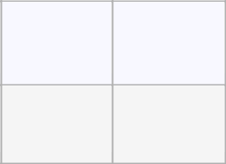

Input | Result
5 | 34568
65438

PROGRAM

- = int(input())

- = list(input().split(" ")) b.sort()

for i in b: print(i,end=" ")

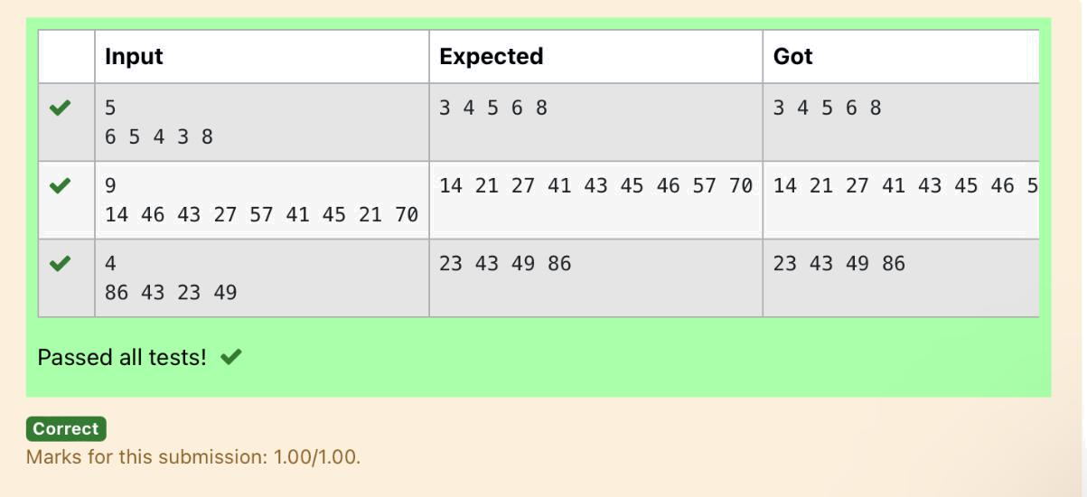

Dept of Artificial Intelligence and Machine Learning | Rajalakshmi Engineering College

. 130

Ex. No. : 10.2 Date: 25/5/24

Register No.: 231501058 Name: M Harish

Bubble Sort

Given an listof integers, sort the array in ascending order using the Bubble Sort algorithm above. Once sorted, print the following three lines:

- List is sorted in numSwaps swaps., where numSwaps is the number of swaps that took place.

- First Element: firstElement, the first element in the sorted list.
- Last Element: lastElement, the last element in the sorted list.

For example, given a worst-case but small array to sort: a=[6,4,1]. It took 3 swaps to sort the array. Output would be

Array is sorted in 3 swaps.
First Element: 1
Last Element: 6

Input Format

The first line contains an integer,n , the size of the list a .

The second line contains n, space-separated integers a[i].

Constraints

- 2<=n<=600

- 1<=a[i]<=2x106.

Output Format

You must print the following three lines of output:

- List is sorted in numSwaps swaps., where numSwaps is the number of swaps that took place.

- First Element: firstElement, the first element in the sorted list.

- Last Element: lastElement, the last element in the sorted list.

Sample Input 0

3

1 2 3

Sample Output 0

List is sorted in 0 swaps.

First Element: 1

Last Element: 3

For example:

Dept of Artificial Intelligence and Machine Learning | Rajalakshmi Engineering College

. 131


Input Result

- List is sorted in 3 swaps.

- 2 1First Element: 1 Last Element: 3

- List is sorted in 4 swaps.

- 9 2 8 4 First Element: 1 Last Element: 9

PROGRAM

num = 0

- = int(input())

- = input().split(" ")

- = []

for i in range(len(b)):

c.append(int(b[i]))

for j in range(len(c)):

for i in range(len(c)-1):

if c[i] > c[i+1]:

c[i], c[i+1] = c[i+1], c[i]

num += 1

print(f"List is sorted in {num} swaps.\nFirst Element: {c[0]}\nLast Element:

{c[-1]}")

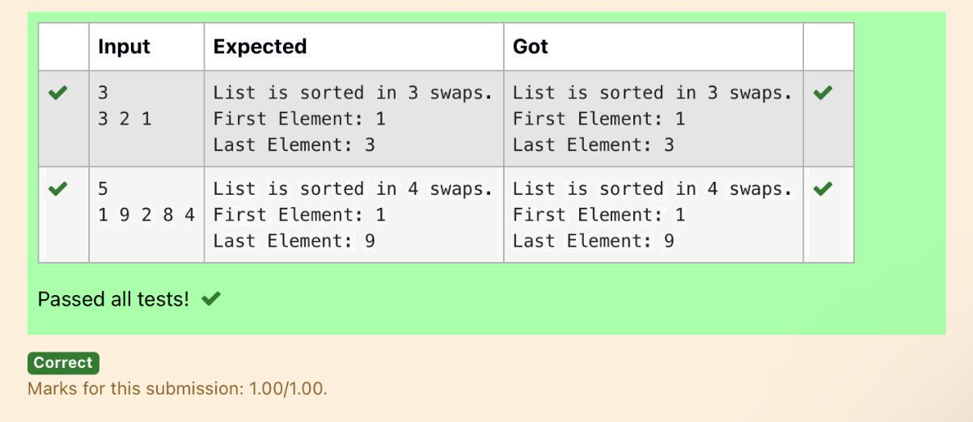

Dept of Artificial Intelligence and Machine Learning | Rajalakshmi Engineering College | . 132

Ex. No. : 10.3 Date: 25/5/24

Register No.: 231501058 Name: M Harish

Peak Element

Given an list, find peak element in it. A peak element is an element that is greater than its neighbors.

An element a[i] is a peak element if

A[i-1] <= A[i] >=a[i+1] for middle elements. [0<i<n-1]

A[i-1] <= A[i] for last element [i=n-1]

A[i]>=A[i+1] for first element [i=0]

Input Format

The first line contains a single integer n , the length of A .
The second line contains n space-separated integers,A[i].

Output Format

Print peak numbers separated by space.

Sample Input

5

891026

Sample Output

10 6

Input | Result
4 | 12 8
12368

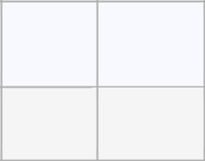

For example:

PROGRAM

n = int(input())

- = list(map(int, input().split())) if n == 1:

print(A[0]) else:

if A[0] >= A[1]: print(A[0], end=" ")

for i in range(1, n - 1):

if A[i] >= A[i - 1] and A[i] >= A[i + 1]: print(A[i], end=" ")

if A[n - 1] >= A[n - 2]: print(A[n - 1])

Dept of Artificial Intelligence and Machine Learning | Rajalakshmi Engineering College

. 133

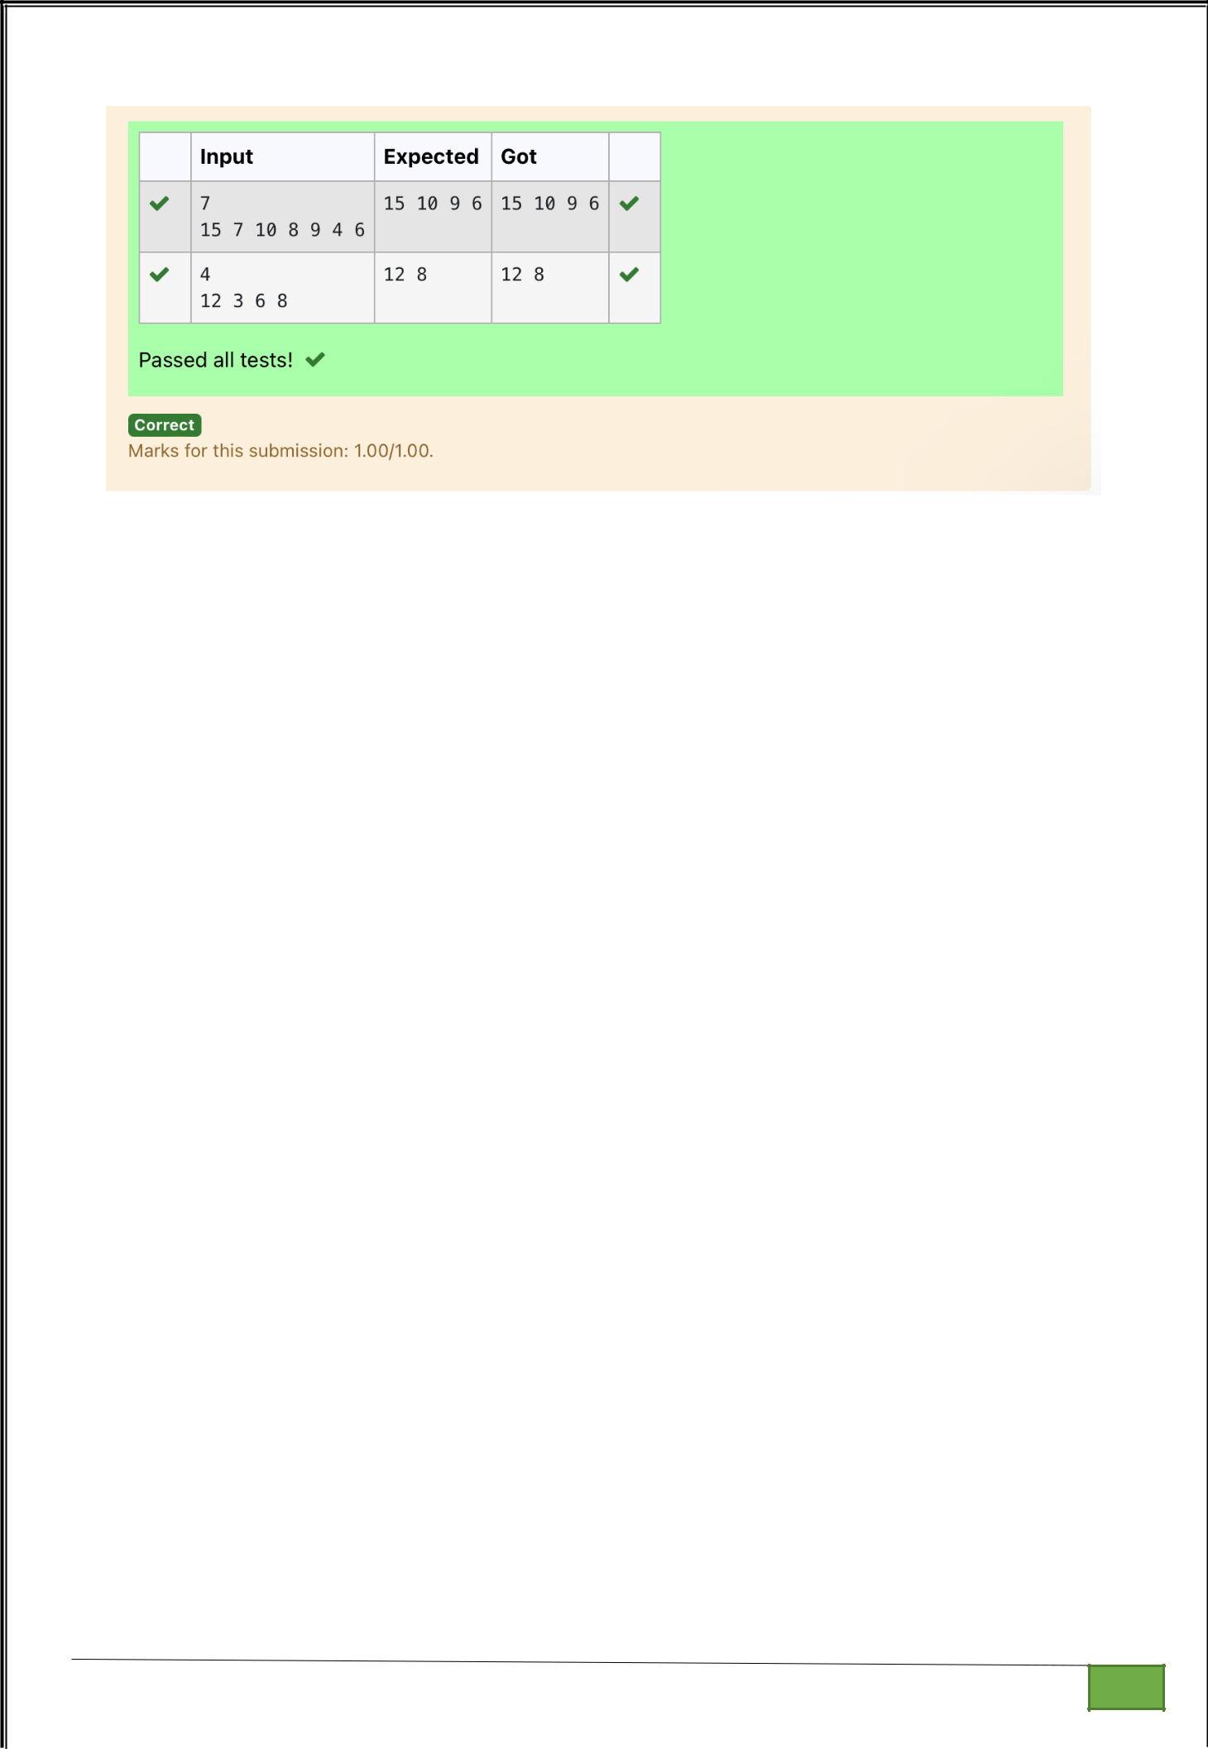

Dept of Artificial Intelligence and Machine Learning | Rajalakshmi Engineering College

. 134

Ex. No. : 10.4 Date: 25/5/24

Register No.: 231501058 Name: M Harish

Binary Search

Write a Python program for binary search.

For example:

PROGRAM

def binary_search(arr, x):

left, right = 0, len(arr) - 1

while left <= right:

mid = (left + right) // 2 if arr[mid] == x:

return True

elif arr[mid] < x:

left = mid + 1

else:

right = mid - 1

return False

Input | Result
12358 | False
6

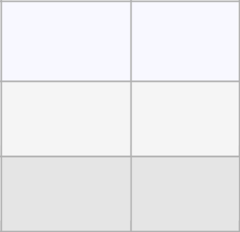

3 5 9 45 42 True
42

arr = list(map(int, input().split(',')))

- = int(input()) arr.sort()

result = binary_search(arr, x) print(result)
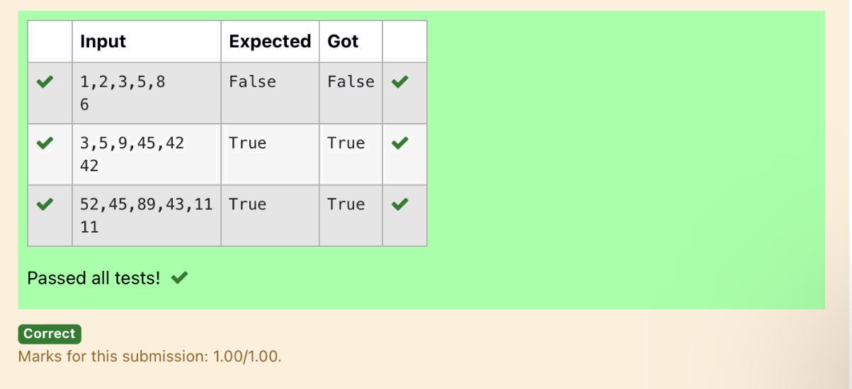

Dept of Artificial Intelligence and Machine Learning | Rajalakshmi Engineering College

. 135

Constraints:


1<=n, arr[i]<=100

Input:

1687949068145

output:

- 2

- 2

- 1

- 2

- 1

90 1

For example:

PROGRAM

numbers = input().split()

numbers = [int(num) for num in numbers] frequency = {}

for num in numbers:

if num in frequency:

frequency[num] += 1

else:

frequency[num] = 1

sorted_frequency = sorted(frequency.items())

for key, value in sorted_frequency:

print(key, value)


Input | Result

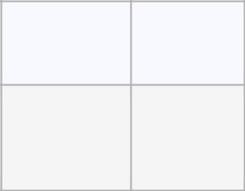

435345 | 3 2
 | 4 2
 | 5 2

Dept of Artificial Intelligence and Machine Learning | Rajalakshmi Engineering College

. 136

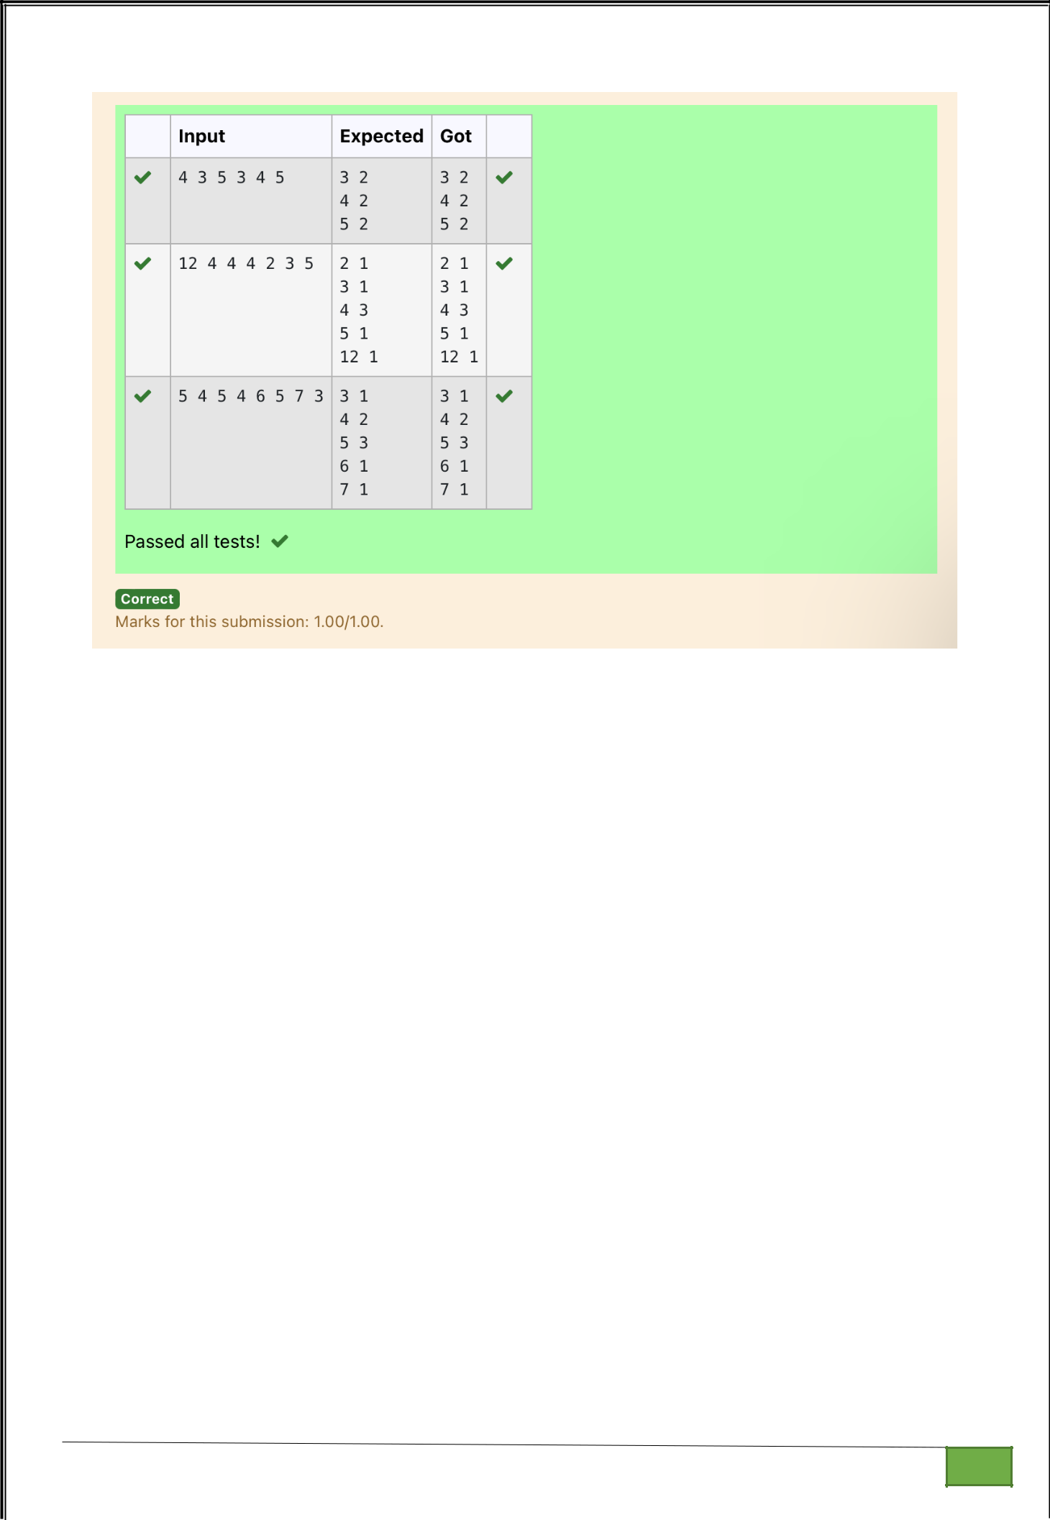

Dept of Artificial Intelligence and Machine Learning | Rajalakshmi Engineering College

. 137

